Bridge Base Online
Playing Bridge Online (for free)
Introduction
There are a number of Websites and Apps where you can play online. These notes are to help Members get started playing Bridge Base Online (BBO). In most instances it is free to play.
You can play via the BBO Website and there is also an App, should your preference be to play on a Tablet or iPad.
These notes are designed to:
- set your Privacy options
- set up a WhatsApp group so you can see and talk to your playing ‘buddies’ when playing with friends
NB: the Privacy options relate to playing on a PC so the screen presentations may vary slightly if you are using the App.
BBO provides for anyone to:
- start a Table (this person is called the ‘Host’) and invite others to a game, (including friends, strangers or robots), or wait to be joined by others
- be invited to join a Table started by a friend (some Members have arranged to play together)
- join a Table where other people are already playing (as people leave others join, including robots), with the person longest at the Table being designated as the ‘Host’)
Registering with BBO
Before you can play, you need to Register (it is free). When registering it is advisable to indicate your Systems (Eg: ACOL; Weak Twos; Transfers; Stayman; Ace Asking; etc) especially if you intend playing with those you do not know.
Miscellaneous
It is relatively easy to play although there is an online help page should you need additional information.
Here are some useful pointers:
You can:
- add friends (NB: this is recommended as the system saves their details – see ‘People’ bar in menu to right of screen)
- the ‘Game Host’ can
  - set the Options for a Game. (NB: there does not appear to be the facility to Save the options so this will need to be done each time you play)
  - invite others to Play
To avoid ‘intruders’ when you are playing with friends, it is important that the options are set correctly. The notes and screen shots on the next two pages of this document explain what to do.
Video Conferencing Whilst You Play
Whilst the system appears to allow for ‘Speak Chat’ (see under ‘Account’ menu to right of screen), to make the game more enjoyable, you might wish to be able to see your friends as you play with them.
There are a number of Video Conferencing systems but at least one group of Members have set up a WhatsApp group. The procedure to set up a Group (once you have downloaded WhatsApp to you phone) is to:
  - go to the ‘Chats’ page
  - click on ‘New Group’
  - add a participant from your Contacts
  - click ‘Next’
  - name the Group (Group Subject)
  - click Create
- To make a Video call
  - click on the Group name
  - click the video icon
  - if WhatsApp doesn’t immediately ring the Group Members, you will be given the option to select the people in the Group you want to chat with
    - make your selection
    - click on the Video icon

Setting Menu Options (for maximum privacy when Starting Table to play with friends)
(NB: the text in RED has been added to each Screen shot)

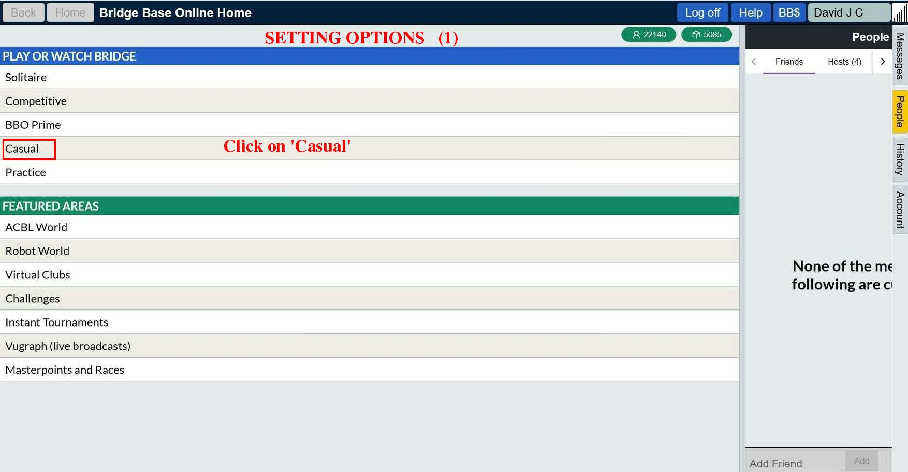

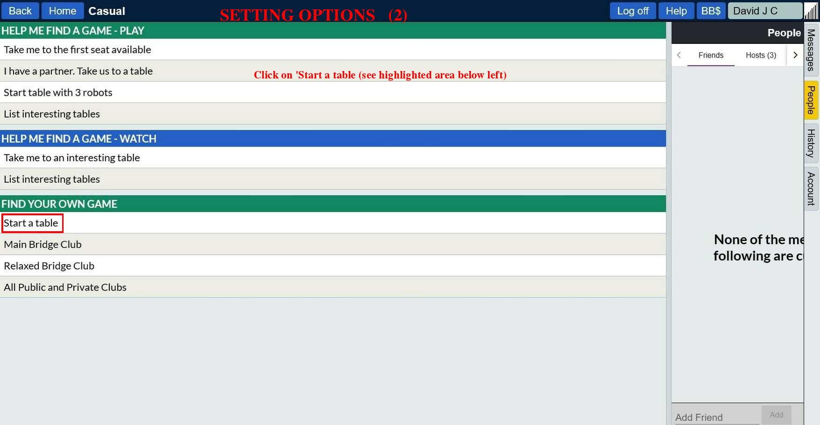

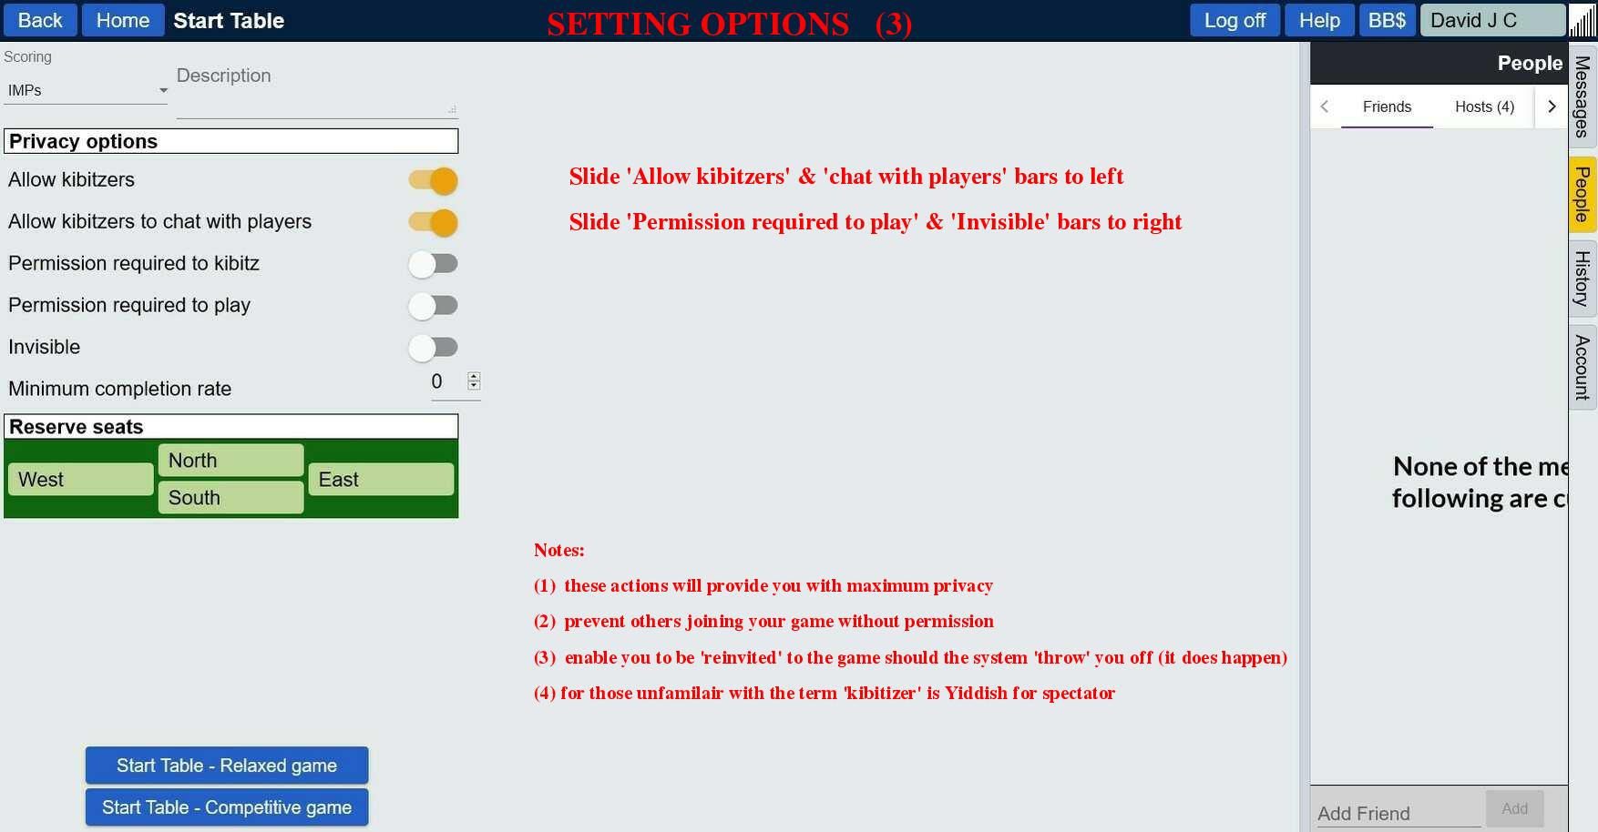

You are now ready to play and the ‘Host’ commences by clicking on ‘Start Table – Relaxed game’ (as shown in screen shot above).
Enjoy.

